NMR Log
Introduction
Nuclear magnetic resonance (NMR) has been, and continues to be, widely used in chemistry, physics, and biomedicine and, more recently, in clinical diagnosis for imaging the internal structure of the human body. The same physical principles involved in clinical imaging also apply to imaging any fluid-saturated porous media, including reservoir rocks. The petroleum industry quickly adapted this technology to petrophysical laboratory research and subsequently developed downhole logging tools for in-situ reservoir evaluation.

- Nuclear Magnetic Resonance (NMR) is the phenomenon whereby a magnetic nuclei absorbs and emits energy in the presence of a magnetic field.
- The first NMR Logging Tools were developed in the early 1960’s.
- Plagued with problems so it was retired in the 1980’s.
- Re-emerged with the advent of pulsed tools.

NMR allows for the calculation of:
- Porosity
- Permeability
- Pore-space distributions
- Producible fluids and Irreducible Fluids
- Reservoir Quality
- Hydrocarbon Quality

Purpose of NMR logging
NMR logging, a subcategory of electromagnetic logging, measures the induced magnet moment of hydrogen nuclei (protons) contained within the fluid-filled pore space of porous media (reservoir rocks). Unlike conventional logging measurements (e.g., acoustic, density, neutron, and resistivity), which respond to both the rock matrix and fluid properties and are strongly dependent on mineralogy, NMR-logging measurements respond to the presence of hydrogen protons. Because these protons primarily occur in pore fluids, NMR effectively responds to the volume, composition, viscosity, and distribution of these fluids, for example:
- Oil
- Gas
- Water
NMR logs provide information about the quantities of fluids present, the properties of these fluids, and the sizes of the pores containing these fluids. From this information, it is possible to infer or estimate (Fig.5.1):
- The volume (porosity) and distribution (permeability) of the rock pore space
- Rock composition
- Type and quantity of fluid hydrocarbons
- Hydrocarbon producibility

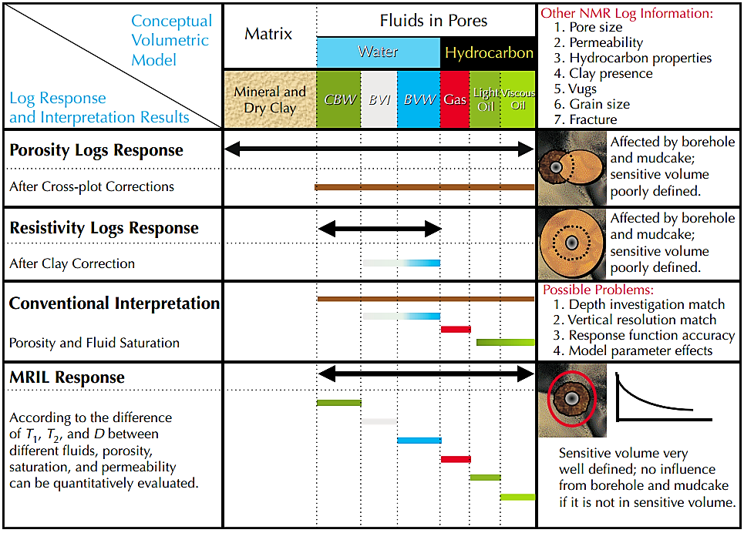
Figure 5.1. MRIL (same principle with NMR) tool responses are unique among logging tools.

NMR physics
Atomic nuclei spin, and this angular moment produces a magnetic moment (i.e., a weak magnetic field). The NMR technique measures the magnetic signal emitted by spinning protons (hydrogen nuclei are the protons of interest in NMR logging) as they return to their original state following stimulation by an applied magnetic field and pulsed radio frequency (RF) energy. These signals, which are observed (measured) as parallel or perpendicular to the direction of the applied magnetic field, are expressed as time constants that are related to the decay of magnetization of the total system.

NMR devices—both laboratory spectrometers and logging tools—use strong magnets to create a static magnetic field ($B_{0}$) that aligns (polarizes) the protons in the pore fluid from their resting (random) state to the direction of the imposed magnetic field (Fig.5.2).

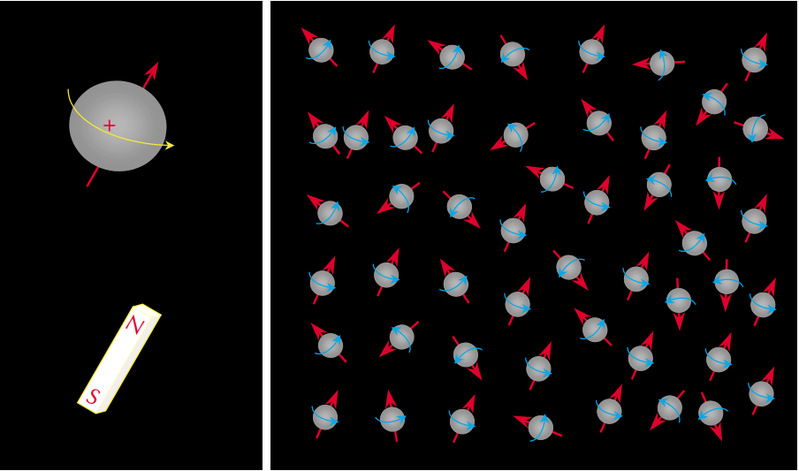
Figure 5.2. – Because of their inherent nuclear magnetism, hydrogen nuclei (left) behave as though they are tiny bar magnets aligned with the spin axes of the nuclei. In the absence of an external magnetic field, the nuclear-magnetic axes (right) are randomly aligned.

Polarization is not instantaneous—it grows with a time constant, which is called the longitudinal relaxation time, denoted as $T_{1}$. Once full polarization (magnetic equilibrium) has been achieved, the applied static magnetic field, $B_{0}$, is turned off.

The protons begin to lose energy as the imposed magnetization, $M_{0}$, decays and the protons fall out of alignment, back to their original orientation and low-energy state. The protons’ angular momentum causes them to behave like tiny gyroscopes, and the loss of energy occurs during a wobbling or axial rotation (called precession) in the direction of the applied magnetic field. $M_{0}$, also known as the bulk magnetization, provides the signals measured by NMR devices. The frequency at which the energy is emitted or is initially absorbed, f, called the Larmor or resonance frequency, is proportional to the strength of the external magnetic field, $B_{0}$, (Fig.5.3). The Larmor frequency is used to tune a NMR probe, permitting it to image very thin slices of a sample at different distances from the tool.

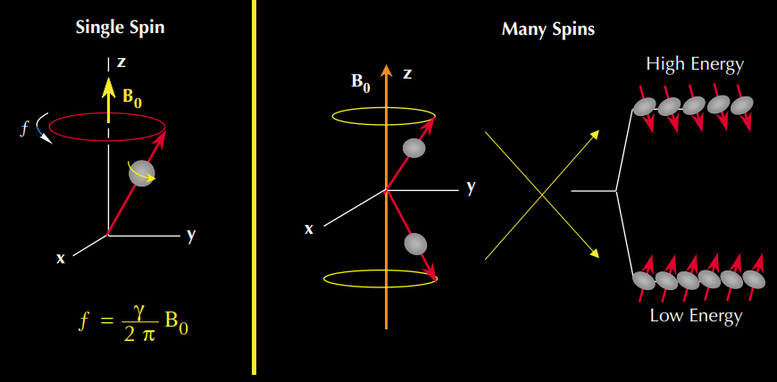
Figure 5.3 – In an external magnetic field, the precessional frequency (f) of a nucleus depends on the gyromagnetic (γ) of the nucleus and the strength of the external field ($B_{0}$).

An antenna detects and records the decaying magnetic field generated by the precessing nuclei. At any given time, t , the strength of this magnetic field, $M_{Z}$, is proportional to the number of protons, the magnitude of $B_{0}$, and the inverse of the absolute temperature (Eq.1):
$$M_{z}\left(t\right)=M_{0}\left(1-e^{\frac{-t}{T_{1}}}\right)⋯∎eq1$$
where $M_{z}(t)$ = the magnitude of magnetization at t, $M_{0}$ = the final and maximum magnetization at a given magnetic field, and t = the time that the protons are exposed to the $B_{0}$ field.

The signal recorded parallel to the direction of the applied magnetic field (z plane) is called $T_{1}$, or longitudinal (spin-lattice) relaxation. $T_{1}$ describes how quickly the protons align within the static magnetic field. The $T_{1}$ curve is an exponential curve that characterizes the rate of change of the proton magnetization (Fig.5.4).
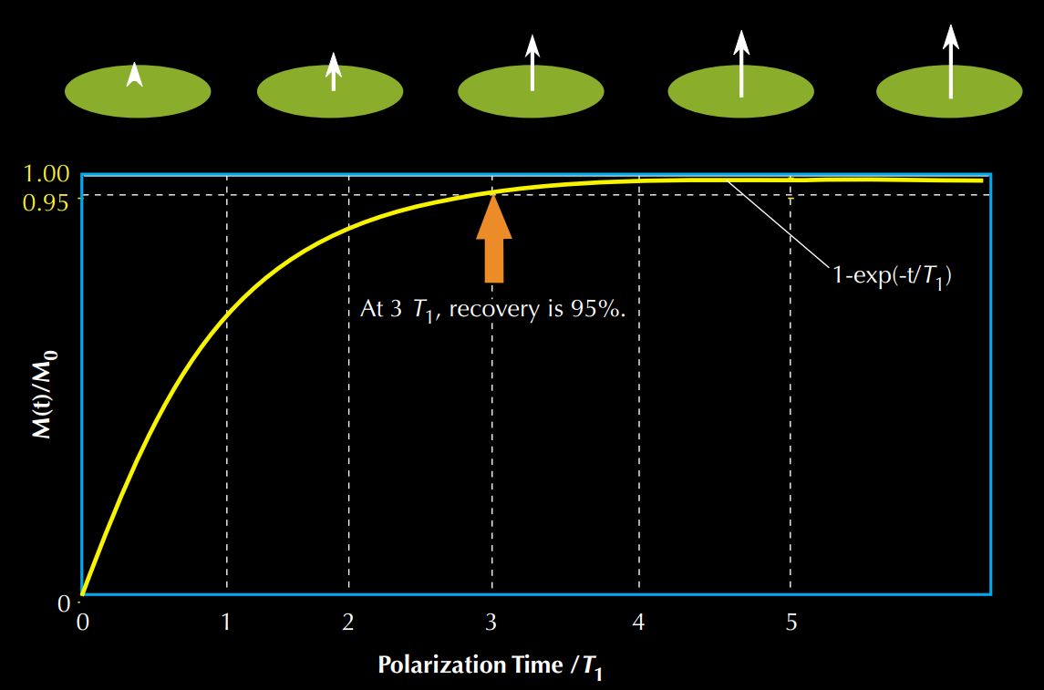
Figure 5.4 - $T_{1}$ relaxation (polarization) curves indicate the degree of proton alignment, or magnetization, as a function of the time that a proton population is exposed to an external magnetic field.
$T_{1}$ is the time at which the magnetization reaches 63% of its final value, and three times $T_{1}$ is the time at which 95% polarization is achieved. Full polarization of typical reservoir-pore fluids may take several seconds. Large values of $T_{1}$ (measured in milliseconds) correspond to weak coupling between the fluid and its surrounding environment and a slow approach to magnetic equilibrium, whereas, small $T_{1}$ values represent strong coupling and a rapid approach to equilibrium. Different fluids, such as water, oil, and gas, have very different $T_{1}$ values. $T_{1}$ is directly related to pore size and viscosity.

Spin-Echo Detection
Pulse NMR devices use precisely timed bursts (pulse sequences) of RF energy that generate an oscillating magnetic field ($B_{1}$) that tilts or "tips" the aligned protons perpendicular (x-y plane) to the direction of the applied magnetic field. The application of $B_{1}$ results in a change in energy state that causes the protons to precess in phase to one another. These changes are known as NMR.
When the $B_{1}$ field is turned off, the precessions of the protons are no longer in phase with one another, and the net magnetization decreases. In this situation, a receiver coil (antenna) that measures magnetization in the transverse direction will detect an exponential decaying signal called free-induction decay (FID); see Fig.5. NMR-logging tools use the same antenna to transmit the RF pulse (kilowatt scale) and receive the decay signal (nanovolt scale).
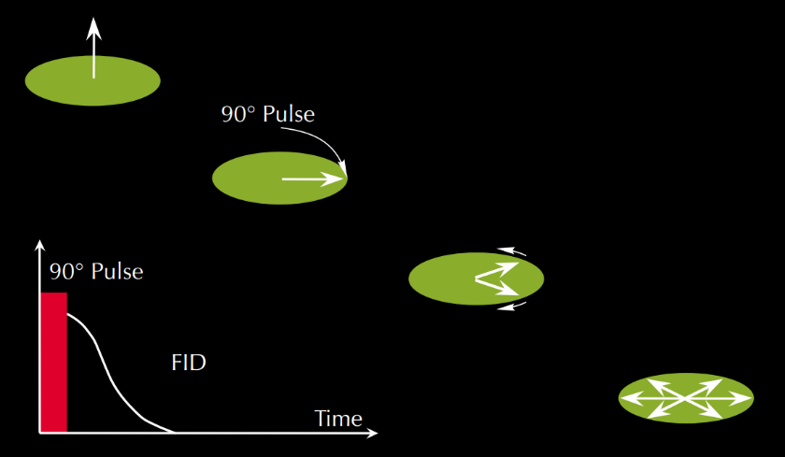
Figure 5.5 – After application of a 90° pulse, the proton population dephases and an FID signal can be detected.
The FID signal measured in the x-y plane is called $T2$ —the transverse or spin-spin relaxation. In contrast to T1, T2 of hydrocarbons is much shorter (see fig5.) in an inhomogeneous magnetic field. The process of spins lossing their coherence due to magnetic field inhomogeneity is not a true "relaxation" process and is dependent on the location of the molecule in the magnet field distirbution. Therefore, the FID decay constant is often referred as T2* rather than T2.
The primary objectives in NMR logging are measuring T1 signal amplitude (as a function of polarization), T2 signal amplitude and decay, and their distributions. The total signal amplitude is proportional to the total hydrogen content and is calibrated to give formation porosity independent of lithology effects. Both relaxation times can be interpreted for pore-size information and pore-fluid properties, especially viscosity.
In the laboratory, T1 is generally measured by either of two pulse sequences: inversion recovery or saturation recovery. Inversion recovery consists of a 180° spin inversion followed by a variable recovery time and then a 90° read pulse. The magnetization vector is entirely in the longitudinal range and, thus, has a higher dynamic range than the other method. Saturation recovery uses a 90° pulse, followed by a 90° read pulse. Saturation recovery is generally considered the more robust and efficient method. Although the actual T1 sampling sequence is very short—involving several short echoes trains, each of which requires only a few milliseconds—the total amount of time required to obtain the number of samples sufficient to define the T1 spectrum is significantly greater.
Depending on the activation used, the computation of a T1 spectrum requires at least 25% more, and sometimes double, the time needed for the computation of a T2 spectrum. In NMR logging, T1 measurement initially required either a stationary mode or very slow logging speeds. With the latest multifrequency tools, a technique used for speeding up T1 measurements is to make simultaneous measurements of the individual steps observed during a T1 recovery experiment in adjacent volumes; at least two such volumes are required. This technique enables T1 acquisition in less time, thereby permitting faster logging speeds.
T2 measurement uses the spin-echo technique, in which the protons are first tipped into the transverse (x-y) plane by a 90° RF pulse and then inverted (flipped) by a subsequent 180° RF pulse at a fixed-time interval to rephase the dephasing protons. Rephasing the protons creates a detectable signal called a spin echo (Fig.6).
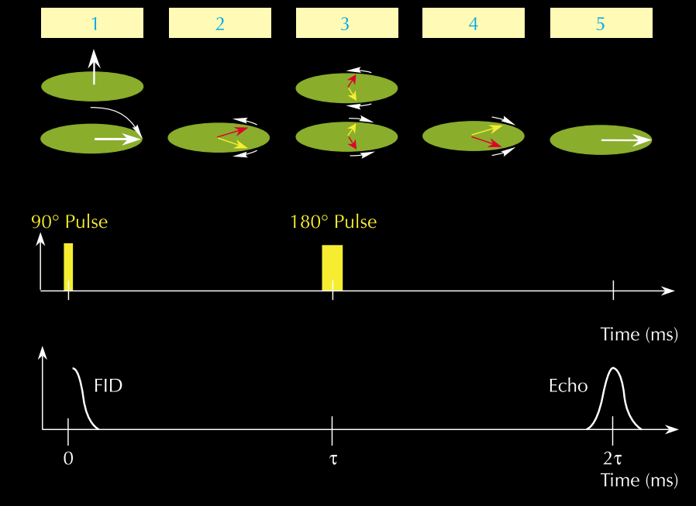
Figure 5.6 – NMR spin echo: (1) to generate a spin echo, a 90° B1 pulse is first applied; (2) after cessation of the 90° pulse, dephasing starts; (3) at τ, a 180° B1 pulse is applied to reverse the phase angles and, thus, initiate rephrasing; (4) rephrasing proceeds; and (5) rephrasing is complete, and a measureable signal (a spin echo) is generated at 2τ.

Nomenclature
B₀ | = | static magnetic field, gauss
B₁ | = | amplitude of the oscillating magnetic field perpendicular to B₀, gauss
M₀ | = | macroscopic magnetization, gauss/cm³
M0x | = | magnitude of the transverse magnetization at t = 0, gauss/cm3
Mx(t) | = | transverse magnetization at time t, gauss/cm3
Mz(t) | = | longitudinal magnetization at time t, gauss/cm3
t | = | time, seconds
x, y, z | = | cartesian space coordinates
T1 | = | longitudinal relaxation time, seconds
T2 | = | transverse relaxation time, seconds
TE | = | CMPG interecho spacing, seconds
TW | = | polarization (wait) time, seconds

NMR-Logging Raw Data
- Total Porosity
$⇝$Initial amplitude of the decay curve is a measure of the amount of
polarized hydrogen in the pore fluid.

- Pore size distribution
$⇝$T2 is smaller at surface area of grains than in pore space therefore
smaller T2 values mean smaller grain sizes.

- Producible porosity and Bulk Volume Irreducible
$⇝$Assuming that producible fluids reside in large pores and non-
producible in small pores, T2 distribution curves
can give the values for producible porosity of a formation.

- Permeability
$⇝$Based on scientific models that show permeability increases with
porosity combined with core data.

- Properties of Reservoir Fluids
$⇝$Based on T1 and T2 times which indicates pore sizes. Clay-bound
water, capillary-bound water, movable water, brine, hydrocarbons can
all be differentiated based on various pore sizes.
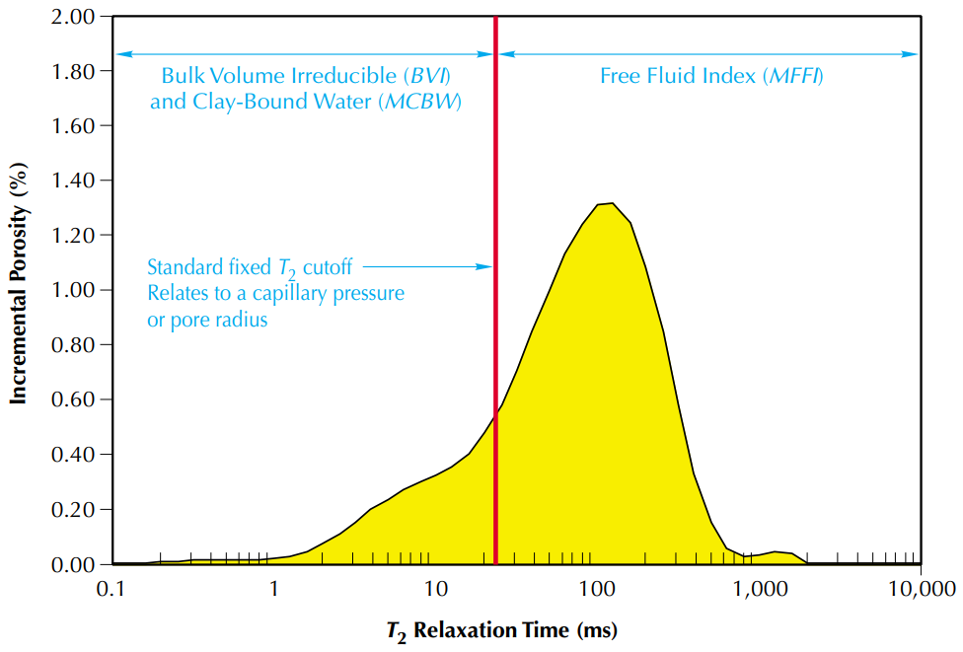
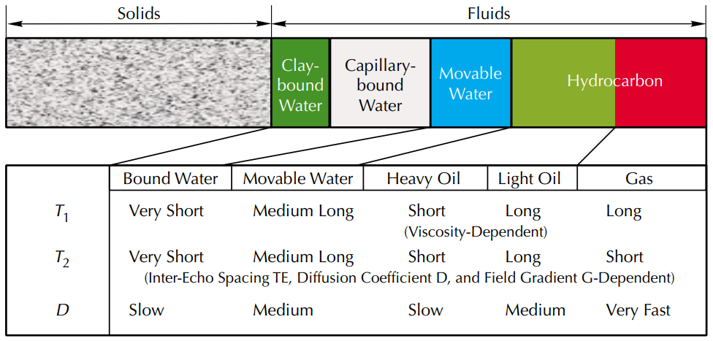
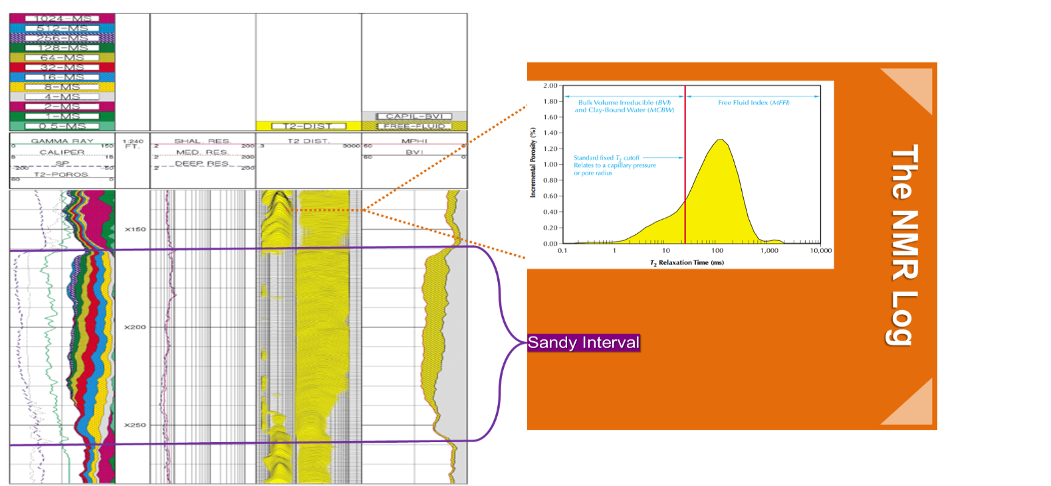
MRIL & CRM
1-Magnetic Resonance Imaging (MRIL) Logging
- Introduced by Numar in 1991.
- Composed of a permanent magnet and antennae.
- Magnet generates a static magnetic field.
- Antennae sends bursts of radio-frequency energy into the formation in the form of an oscillating magnetic field.
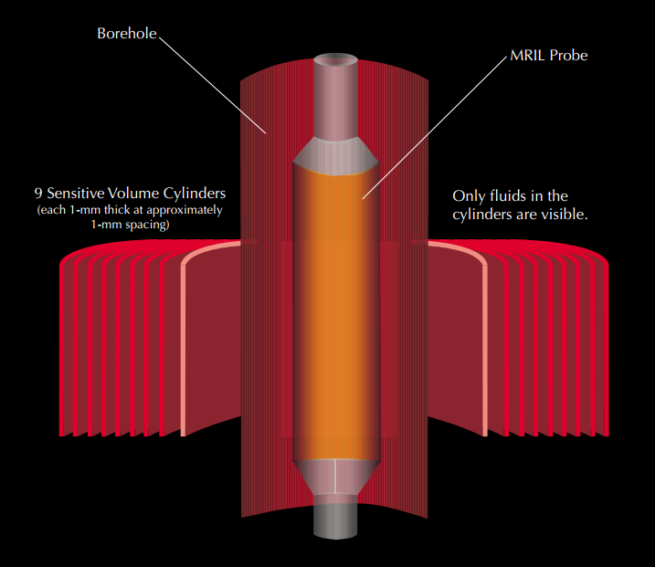
- Antennae acts as a receiver for decaying echo signal.

2-Schlumberger Combinable Magnetic Resonance (CRM) tool
- Introduced by Schlumberger in 1995
- Uses a bowstring to press against borehole
- Antennae sandwiched between two permanent magnets
- Creates a sensitive zone of about 6 by 1 inches in the formation
- Used for high resolution data and high-precision
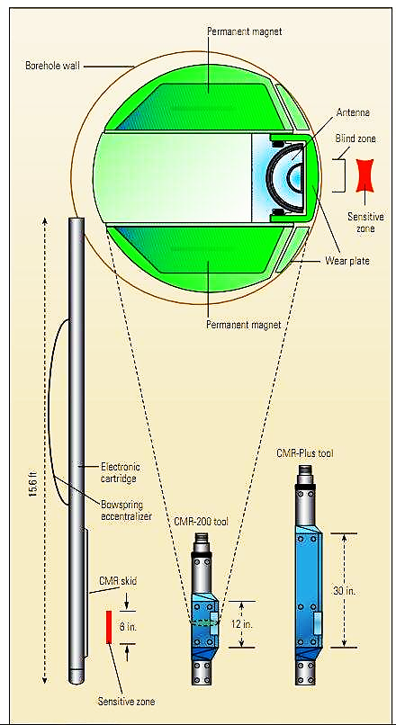
Advantages & Disadvantages of NMR
- Only fluids are visible to NMR technology so porosity. measurement is independent of the lithology.
- Producible zones with high percentage of clay-bound water can be identified.
- A better measurement of permeability is possible than traditional plots.
- In-situ measurement of oil viscosity.
- Differentiation of oil/gas zones.
Advantages of NMR
- Any diamagnetic or paramagnetic ions present in the formation can affect the tool response.
- Expensive.
- Slower logging speeds.
- Slimhole tools are not available.
- Shallow depth of penetration.
- Permeability measurement is actually an empirical measurement and should only be used to compare to permeabilities.
Disadvantages of NMR

Advances In NMR & Future Research
- High- Resolution NMR- allows for the evaluation of producibility of thinly laminated beds.
- Lithology Independent NMR Total Porosity- NMR is the most accurate tool for measuring the porosity of heterogeneous formations.
- Density/ Magnetic-Resonance Method- combines density and NMR log to predict gas-bearing formation total porosities.
- Multi-dimensional NMR Fluid Characterization- composes 2D and 3D maps used to visually identify fluids present in the reservoir on the basis of contrasts in relaxation time.
Advances In NMR

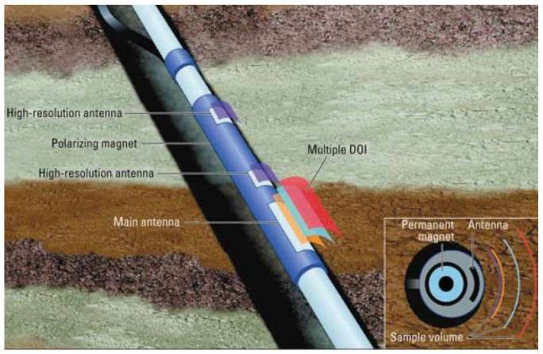
- Imaging reservoirs the same way MR is used to image the human body.
- Inferring rock wettability from NMR.
- Pressure/Volume/Temperature properties of reservoirs • Define rock/pore-space connectivity and structure.
Future Research

